Question 1:

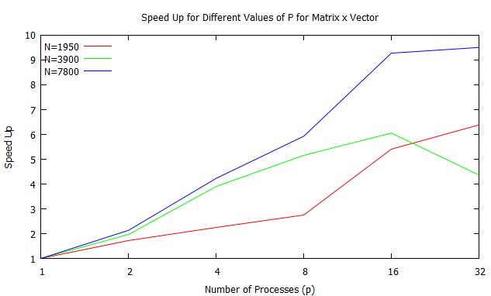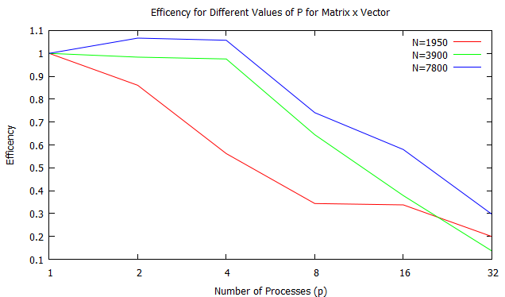

Question 2:

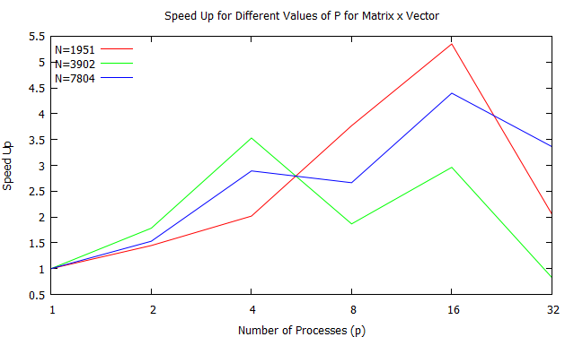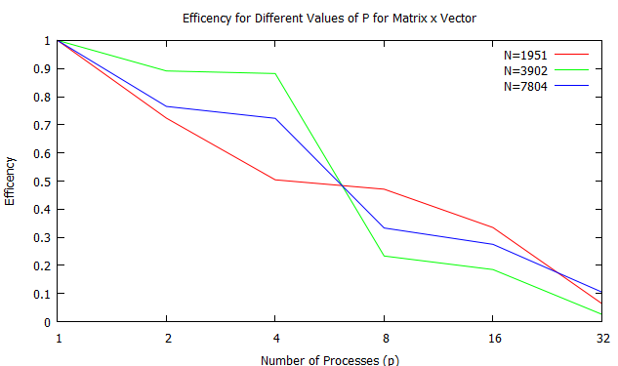

Question 3:

A2perf Performance:

The speed up is fairly definitely increasing nicely to at least 16 processors. It begins to plateau for 32 processors. This suggests that the communication between each process is becoming more of a burden on the run time.

A2perf Scalability:

The efficiency of the program seems to be greater than 1 for a couple values which is probably inaccurate because we shouldn't expect superliner speed up because we are not managing the memory for that intent. The efficiency drops quite low but the important thing to note is that all three curves follow a similar pattern. This suggests that it is weakly scalable because an increase in both problem size and number of processors results in about the same efficiency.

A2perf2 Performance:

Although the data did not come out the greatest it is still evident that around 16 processors our speak up peaks. At 32 processors the communication actually appears to be hindering the performance to the point that the speed up is much less than with p=16. This is similar to A2perf.

A2perf2 Scalability:

For this sample the program appears to be weakly scalable as an increase in both problem size and number of processors is about the same. It is not strongly scalable because the efficiency does decrease it is weakly scalable because they all decrease about the same. Similar result to A2perf.

Max Values of N:

The max value of N I achieved was ~7800 for question 1. At 8000 there was an allocation error for p = 1. The error was: PROCESS 0: MALLOC COULD NOT ALLOCATE 64000000 ELEMENTS OF SIZE 8 BYTES which essentially means I am using more than the 1GB that was allocated to the sqjob. There was a similar error for question 2, however, I was able to obtain N=7804. These should be similar because the limiting factor occurs at p=1, in other words when the entire program is executed in series. It would be important to note that the programs are able to handle much larger values of N when the number of processors is higher.